Help! For the Helpers: Implementing RESILIENCE as a Practice.

THE 4 RESPONSES to CRISIS
1) Solve

2) Survive

3) Accept

4) Adapt

5) Stay Miserable

THE GRIEF PROCESS TASKS
Totally accept the loss has occurred

Experience the pain of the loss

Adjust to the new environment

Reinvest in the new reality

Be a “Captain Bounceback” Like Paul
Paul had some difficulties. 2 Corinthians 11:22-31 and 12:7-10
- Thorn in the flesh
- Shipwrecked
- Imprisoned
- Beaten/Stoned
- Endangered

Ultimately, because Jesus called him, Paul bounced back.
Not because of his self-reliance but because of his resilience in Christ. Acts Ch. 9

Explore reasons for RESILIENCE
STRESSORS:
- Finances
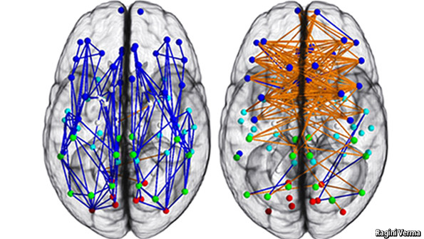
- Family and Relationships
- Job Stability
- Fast Pace of Life
- Health
RESPONSES:
- Feelings

- Speech

- Input

- Focus

Understand the characteristics of RESILIENCE
ELEMENTS OF RESILIENCE ~ Susan Kobasa
CHALLENGE: Resilient individuals view a difficulty as a challenge, not a paralyzing event. They see mistakes as lessons to be learned from and opportunities for growth. Difficulties have no negative reflection on their ability or worth.

COMMITMENT: Resilient individuals commit to life and daily goals and are compelled to live life accordingly. They are committed despite feelings about those commitments.

PERSONAL CONTROL: Resilient individuals spend time and energy on situations that can be influenced, which increases confidence. They spend no time worrying about uncontrollable events, which reduces helplessness.

VIEW OF SETBACKS ~ Martin Seligman
PERMANANCE: Resilient individuals see the effects of bad events as temporary rather than permanent. They expect that the difficulties of this time will resolve or be handled in such a way that they will not continue to affect one negatively.

PERVASIVENESS: Resilient individuals deal with setbacks or bad events in relation to that part of their daily life. They are unwilling to let a difficulty in one area affect other unrelated areas.

PERSONALIZATION: Resilient individual do not exclusively blame themselves when external negative events occur. They ensure that the full picture of how causes interact is considered.

LEARNED ATTRIBUTES ~ Cal Crow
POSITIVE IMAGE OF THE FUTURE: Resilient individuals envision brighter days ahead and see past the difficulty of the present. They harness their ability to look over what is current and to paint a picture of what will be.

EMPATHY & COMPASSION: Resilient individuals do not waste time worrying what others think of them. They feel for others, but not with them. They encourage and support but do not bow to peer pressure and they enforce limits and boundaries.
LACK OF VICTIM MENTALITY: Resilient individuals discern the difference between being a victim and being victimized. They focus time and energy on changing things that they have control over and letting go of those they do not.

Identify RESILIENCE in self and others

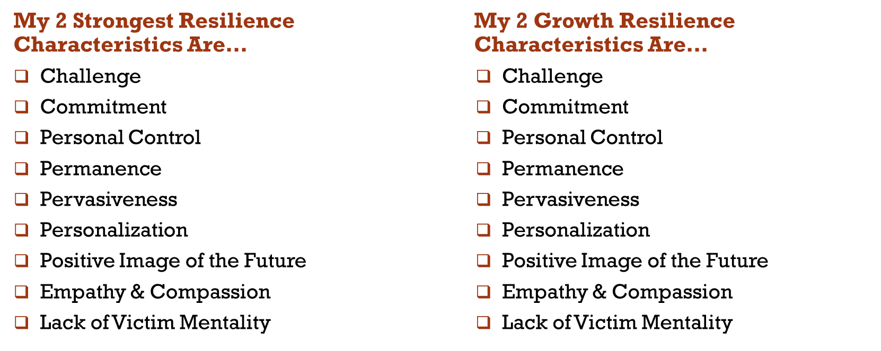

Incorporate RESILIENCE into your life

I will increase my STRENGTH in the
__________________________ resilience charachteristic by:

I will increase my GROWTH in the
__________________________ resilience charachteristic by:

Appreciate RESILIENCE in those around you
Proverbs 22:6 ~ Train up a child in the way he should go and when he is old, he will not turn from it.

RESOURCES:
Presentation Sources:
America Academy of Pediatrics. Healthychildren.org “Positive Parenting and COVID19” Sourced 4/29/2020.
Backus, W. and Chapian, M. (2000). Telling yourself the truth. 2000, Bloomington MN: Bethany Publishing House.

Cary, Phillip. “Good news for anxious Christians/10 practical things you don’t have to do.” Baker Publishing: Grand Rapids, MI, 2010.
Kübler-Ross Elisabeth. (1993). On death and dying: what the dying have to teach doctors, nurses, clergy, and their own families. New York: Collier Books.
Linehan, Marsha M., (2015). DBT skills training manual: second edition. Guilford Press.
Resilience resources adapted from the works of:
Kolbasa, S., et. Al. (1982). Hardiness and health: A prospective study. Journal of Personality and Social Psychology, 42(1), 168-177.

The collected works of Cal Crow, Program Director, Center for Learning and Connections.

The collected works of Martin Seligman, University of Pennsylvania, 2001-2011.

Additional Resources:
Christian Family Solutions: 800.438.1772 www.ChristianFamilySolutions.org

National Mental Health Helpline: 800.273.8255

National Alliance on Mental Illness: www.nami.org

The JED Foundation: www.jedfoundation.org

Suggested Reading:
Saunders, S. (2016). A Christian guide to mental illness: volume 1. Milwaukee WI: Northwestern Publishing House.

Twenge, J. (2017). iGen:why today’s super-connected kids are growing up less rebellious, more tolerant, less happy – and completely unprepared for adulthood and what that means for the rest of us. New York: Atria Publishing.

